Partners4Recovery.org

Funding Application

This application is for funding for Genesee County Specialty Courts, ie; Drug and Sobriety.
You may seek funding for such things as:
- Drug Tests
- Bus Passes
- ARM Weekend

We DO NOT fund:
- Medication
- Personal Items
- Legal Fees

Please submit this application at least 2 weeks prior to needing funding for your particular need. We are asking that you use this application for funding in good faith if you have a monetary necessity.

Applicant Information

Full Name: |  |  |  | Date:
 | Last | First | M.I.

Address:
 | Street Address | Apartment/Unit #

 | City | State | ZIP Code

Phone: |  | Email

Soc.Sec. (last 4)

I am seeking funds for help with:

Name of court I participate in:

Name of Judge:
Name of Probation Officer:

Motivation to maintain recovery (circle one) 1 2 3 4 5 6 7 8 9 10

Court participants must remain in compliance and in good standing with court guidelines to have money allocated to them for financial help for drug tests and bus passes. In addition, if funds are available, we will help fund ARM which is an educational class for court participants who have been sanctioned.

References
Please list one professional reference that will help you vouch for needing financial assistance.

Name Address

City Phone  Email  May we contact your reference for information in this regard? | YES | NO

Consent, Disclaimer and Signature
I certify that my answers are true and complete to the best of my knowledge.
I also give permission to Partners4Recovery.org to be able to contact anyone listed in my application above regarding verifying my court participation. This consent ends with my termination or completion of my existing court program.
If this application leads to funding, I understand that false or misleading information in my application or interview may result in no future funding.
Signature: |  | Date:

Funding Eligibility Financial Guidelines

Participants need to be eligible under these guidelines to qualify for financial help. Please provide 30 days of check stubs to substantiate your eligibility status. Partners4Recovery reserves the right to make funds available to participants who may need help outside of these guidelines.

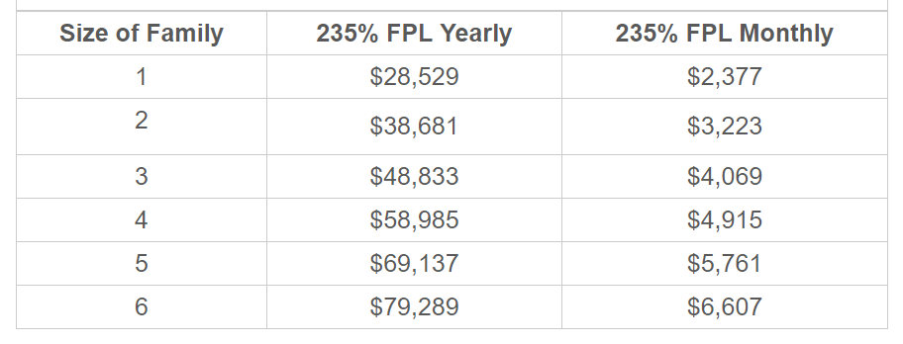

*FPL – Federal Poverty Level

